THIS IS YOUR COVER PAGE

# Introduction

The study of the strategic management of nursing workforce has gained in importance with the increasing trend on nursing shortage. It is understandable that there are more challenging issues in this industrial due to its special background requirements and long-term training in workforce (Bleich, et al., 2003). This paper presents literature reviews on the crucial components of strategic workforce planning in nursing industry and lists the challenges though understanding and formalising the current industry examples. Following that, the result and management implications are discussed at the end of this study.

# Literature review

## Business objectives

Unlike other industrials, hospitals or healthcare institutes are normally profit driven and normally they are shortage on workforce due to the impending retirement of current experienced nurses and long-term training sessions for new recruits (Klug, 2009). The overall demand for labour is increasing even though the governments have established many federal funding programmes.

For example, the government of the Commonwealth of Australia has initialised a rural clinical schools program in 2006 and expected to provide 25% more of current medical students who has around half experience on clinical training, the expected outcome is that this policy will encourage medical workforce recruitment and retention. However, considering the large investments on this programme, the results are not satisfactory despite the fact that there is a small increasing in pursuing a career in certain areas. This phenomenon is not only in Australia but world widely (Baker, 2007).

## Existing workforce

It is evidentially to say that the nurses are highly demanded but lower on supply, according to the report from Australian Department of Health, there were 273,404 registered nurses and almost 60,000 enrolled nurses who are only working under supervised condition. From 2009 to 2012 there is a steady 3 percent increase in total number of registered nurses and enrolled nurses as shown below.

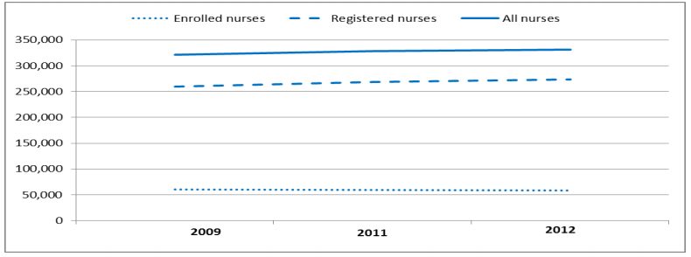

Figure 1 Overall number of nurses in Australia (Health, 2014)

However, it is wide acknowledged that average age of both type of nurses is 44.2 years old, and the percentage of nurses who aged 55 and over is increased from 19.9% to 22.5% while only 22% of nurses are below 35 , which results an expected labour shortage in this industry in the future (Health, 2014). Beside this point, more than 90 percent of the nurses are female and majorly focus on aged care, medical and surgical. Even with the help of international immigrates from other countries, the overall number still cannot cover the shortages among the hospitals and healthcare institutions due to the fact that overseas account for 13% of the total nursing population.

Despite the fact that there is a shortage on workforce supply, the overall nursing population is not in a healthy status, mainly due to the cost of hiring them and the time and investment for training into a “ready to working” state (Baumann, 2016). As a result, most of nursing workforce are either underemployed or unemployed, which give the public a strong signal that the career of nursing contains more uncertainty. The medias are playing a bad role consider the negative reports which result a steady decreasing on nursing enrolment.

The nursing workforce planning is suffering not only the shortage problem but also the education problems. Some nurses are not undertaking enough education and training before they start their career, in this case, the originations do require more investment and time in order to have suitable position in this industry. However, because of this, the organisations only hire part time and causal enrolled nurses under such circumstances.

## Future Need

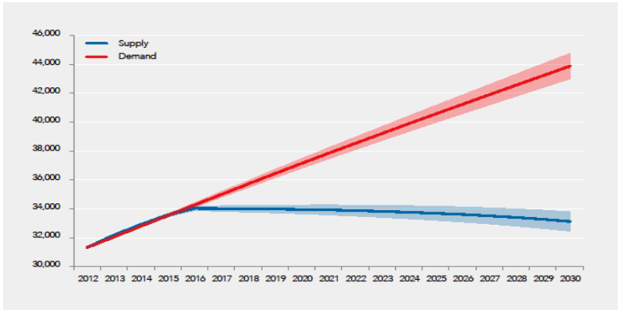

Figure 2 Supply - demand in nursing industry (Health, 2014)

Regardless current governmental funding or development of nursing organisations, the supply of nursing employees is peak in 2016, and steady stay constant at 34,000 from 2017. However, with the age gap of both type of nursing workforce continually raising, there is a significant retirement number in the near future due to the expected retirement crisis in 2019 to 2020, moreover, some government-funded remote primary care clinics have taken some market shares with agency-employed nurses even with an extremely high annual turnover rates (Deborah J Russell, 2017). By 2030, there is a 70 percent registered nurses, 25 percent enrolled nurses and 5 percent AINs (Assistant in Nursing)/PCAs (Personal Care Assistant), the total workforce increases from 121,852 to an expected 158,578 (Health, 2014). This increasing still cannot negate the significant increasing market demands.

## Gaps in the workforce

The major gaps in the health workforce are different from other industries (Allison Squires PhD, 2017), for example, although micro level nursing workforce problems like financial position or daily overtime, cost of training and work arraignment are not requiring particular mandatory considerations. However, for this specific industry, the impending nursing shortage world widely, the knowledge gaps among experienced and inexperienced nurses as well as in the socially disadvantaged rural communities are the significant issues.

Even though the knowledge gaps can be ceased by internship with long term training (Gledhill, Allchorne, Green, & Cornford, 2018), which is expensive and counterproductive, the time needed from nursing trainees to qualified nurses are insufficient for hospitals and healthcare institutions, especially the private ones.

In addition, in order to negate the shortage crisis, many institutes tend to hire nurses from immigrates, however, some of them do not have competent English ability, which not only creating misunderstanding when perform team tasks but also create some gaps between workforce due to the potential stereotype threats toward to each other. This can be neutralised by initialising diversity awareness trainings in order to educate employees about the diversity awareness and arrange social activities for clear the common misunderstanding between employees.

# Result

From the review of literature, the result can easily find out that the major challenging concern of workforce planning in this specific industrial is the shortage of current supply and predicted future supply on the market. On the contrast, the demand on the market is increasing due to multiple reasons, for example, the overall increasing demands on ageing care sector is increasing with the increasing percentage of ageing population. The ageing problem is not only affect the overall workforce supply but also within the workforce, around 78% of the total workforce are over 35 years old, while almost 90% of them are female. The speciality in this workforce are considered challenging for management and planning.

According to the previous study and report, despite the fact that there is a severe nursing shortage now and, in the future, registered nurses and enrolled nurses are still been fired or been transferred to part-time or casual due the increasing education level requirements which is hard to change for individuals, those decisions do have some negative outcomes. For example, this report suggests that the hospital institute in Canada, UK, US and Australia have short on nursing workforce but the overall register nurses have been unemployed or underemployed which is realising a strong signal to the public that there are uncertainty of nursing career (Linda O’Brien-Pallas, Stephen Birch, & Gail Tomblin Murphy, 2001). Which results a steady decreasing in enrolment of nursing school.

# Management implications

Generally, there is a noticeable disconnect between human resources department and the departments which doing the executions (Dubois, 2003), especially in incompetent organisations. This is not relatively important in some industries which require less skills, however, this misunderstanding is one critical issue in nursing industry. The challenging issues workforce planning for human resources workers in this area are listed as below:

* In order to make enrolled nurses have the required skills to achieve better performance, trainings have to be arranged. This may potentially generate tension between HR department and the execution department.
* The cost for hire skilled registered nurses is higher than other nurses from general training, which results more enrolled nurses get hired and skilled nurses are either underemployment or unemployment from organisation. This may penitently decrease the overall morale and loyalty, which leads to another problem. In addition, the enrolled nurses may need to undertake multiple training sessions, which increase the overall investment in training when start a new labour hiring session
* To solve the overall shortage of workforce, the organisations are required to introduce additional overtime for individuals and increasing their salary into a competitive level in the market. Or perform enough training session for employees which is a non-zero–sum situation. Therefore, the overall happiness and satisfaction of already employed nurses are higher than other industries.

# Conclusion

The overall workforce in nursing industry is facing shortage and ageing problems nowadays, which generated lots of challenges for workforce planning. This study has confirmed that the shortage of workforce has become one important reality factor for the next few decades, due to the market demands and the misleading understanding among nursing educations. Under such circumstance, the management implications for hospitals and healthcare institutes have significant different characteristics from other industries. The overall cost for training or hiring are higher, and organisations may need more resources like time and investment, however, the happiness and satisfaction of individual nurse who are already employed are noticeable higher than other industries.

# References

Allison Squires PhD, R. F.‐B. (2017). A scoping review of nursing workforce planning and forecasting research. *Journal of Nursing Mnagement*, 587-596.

Baker, D. S. (2007). Will Australian rural clinical schools be an effective workforce strategy? Early indications of their positive effect on intern choice and rural career interest. *The Medical Journal of Australia*, 3.

Baumann, C.-A.-D.-C. (2016). Strategic Workforce Planning for Health Human Resources: A Nursing Case Analysis. *The Canadian Journal of Nursing Research*, 93-99.

Bleich, PhD, M. R., RN, CNAA, Hewlett, PhD, P. O., . . . RN. (2003). Analysis of the Nursing Workforce Crisis: A Call to Action: Despite the urgent need, we still lack a national strategy designed to avert the nursing shortage. This review may provide a foundation for such a plan. *AJN The American Journal of Nursing*, 66-74.

Deborah J Russell, Y. Z. (2017). Patterns of resident health workforce turnover and retention in remote communities of the Northern Territory of Australia, 2013–2015. *Human Resources for Health*.

Dubois, G. D.-A. (2003). Human resources for health policies: a critical component in health policies. *Human Resources for Health*.

Gledhill, R., Allchorne, P., Green, J., & Cornford, P. (2018). Knowledge gaps in prostate cancer treatment between physicians and clinical nurse specialists. *International Journal of Urological Nursing*, 5-8.

Health, A. D. (2014). *AUSTRALIA’S FUTURE HEALTH WORKFORCE – Nurses.* Canberra: Department of Health.

Klug, S. H. (2009). Recruit, Respect, and Retain: The Impact of Baby Boomer Nurses on Hospital Workforce Strategy-A Case Study. *Creative Nursing*, 70-4.

Linda O’Brien-Pallas, R. P., Stephen Birch, D. P., & Gail Tomblin Murphy, R. M. (2001). Integrating Workforce Planning, Human Resources, and Service Planning. *Human Resources for Health Development Journal, 5*.